- UK GDP disappointed again in May, with output falling for the second consecutive month. While a combination of noisy data, residual seasonality issues, and one-off factors has exaggerated the loss of momentum in recent months, May's weaker outturn suggests GDP was broadly flat in Q2.
- The Bank of England's Financial Stability Report echoed our warnings that the impact of past interest rate rises is still to fully feed through to households. Alongside tighter fiscal policy and the drag from US trade policy, we think this will keep GDP growth sluggish in the coming years.
It's been a very quiet week, with May's GDP data being the economic release of note. After a particularly strong performance in Q1 2025, GDP releases since then have come in much softer. May's data continued in that vein, with the Office for National Statistics reporting that GDP fell for the second consecutive month, albeit only by a marginal 0.1% m/m. This was below the consensus forecast for a 0.1% m/m rise.
Delving into the detail, the modest decline in activity was partly driven by a weak reading for consumer-facing services (Chart 1). This largely reflected a chunky fall in distribution output, which was consistent with the month's disappointing retail sales results. The manufacturing sector, which is most exposed to changes in trade policy, saw output decline again, while construction activity also fell. Together, this was more than enough to offset a rebound in non-consumer-facing services output, as legal services activity recovered from a slump a month earlier following the stamp duty threshold change at the end of March.
Our takeaway from recent GDP releases is that the data remains very noisy and continues to show signs of residual seasonality, with stronger momentum seen at the start of each year being followed by an abrupt slowdown. This pattern has likely been exaggerated this year given some of Q1's sharp pickup reflected one-off factors, including an unusual spike in aircraft purchases and a large rise in exports to the US as businesses attempted to get ahead of changes in US trade policy. We think the underlying picture over H1 2025 was more benign. Nevertheless, May's softer GDP reading suggests output is likely to have remained broadly flat across Q2 as a whole and well short of the 0.7% q/q expansion seen in Q1.
Chart 1: Consumer-facing services, manufacturing, and construction all weighed on GDP in May
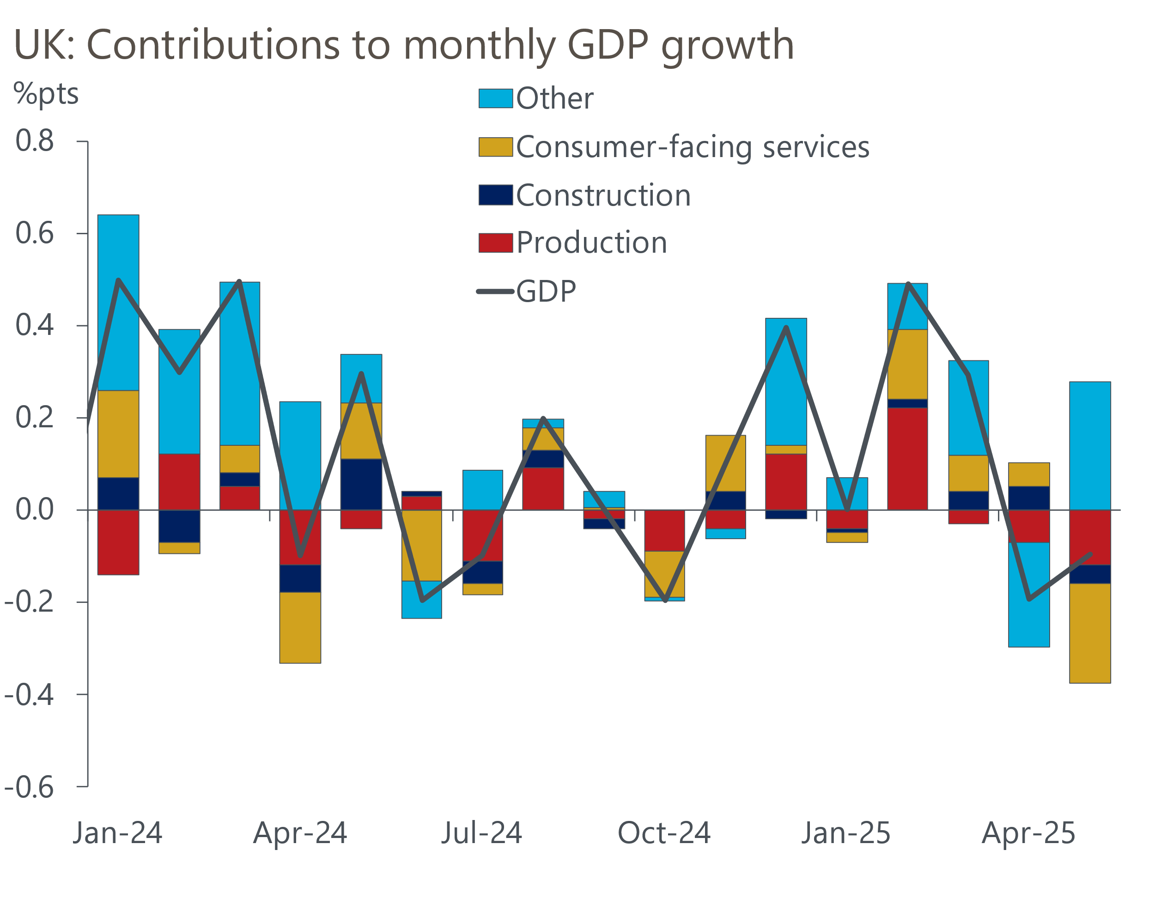
Source: Haver Analytics

Looking ahead over the next couple of years, we expect the economy to grow at a relatively sluggish pace. This reflects the combination of soft underlying momentum, alongside the drags from US trade policy, tighter fiscal policy, and the lagged impact of past interest rate rises continuing to emerge. The latter factor echoes a key finding in the Bank of England's latest Financial Stability Report published earlier this week, namely that the impact of past rate hikes continues to dominate due to the slow passthrough of policy rate cuts to household interest rates.
We have long made the argument that there is still a significant minority of homeowners who are yet to refinance from cheap mortgage deals, often taken out before the BoE started its rate rising cycle at the end of 2021, to higher rates. The BoE estimates that roughly 30% of mortgage accounts haven't refixed since H2 2021, and that most of those borrowers will have a fixed rate deal that expires in the next couple of years.
The BoE anticipates that this factor will more than offset the impact of falling repayments for households refixing shorter deals at lower rates and those who are on variable-rate mortgages. Indeed, the Bank expects a typical mortgagor rolling off a fixed-rate deal in the next two years to experience a £107 increase in monthly mortgage payments.
While we plan to explore this topic in much more detail in a forthcoming Research Briefing, the BoE's findings are consistent with our own forecast. We estimate that mortgagors coming to the end of a five-year fix this year and next, will face an uplift in their interest rate of 200-250bps (Chart 2). Moreover, the scale of this increase in costs should more than offset the impact of cheaper short-term fixed-rate deals and variable-rate loans. Therefore, we expect the average interest rate on outstanding mortgages to continue to grind upwards over the next few years.
Chart 2: Many mortgagors still face refinancing at much higher rates over the next couple of years
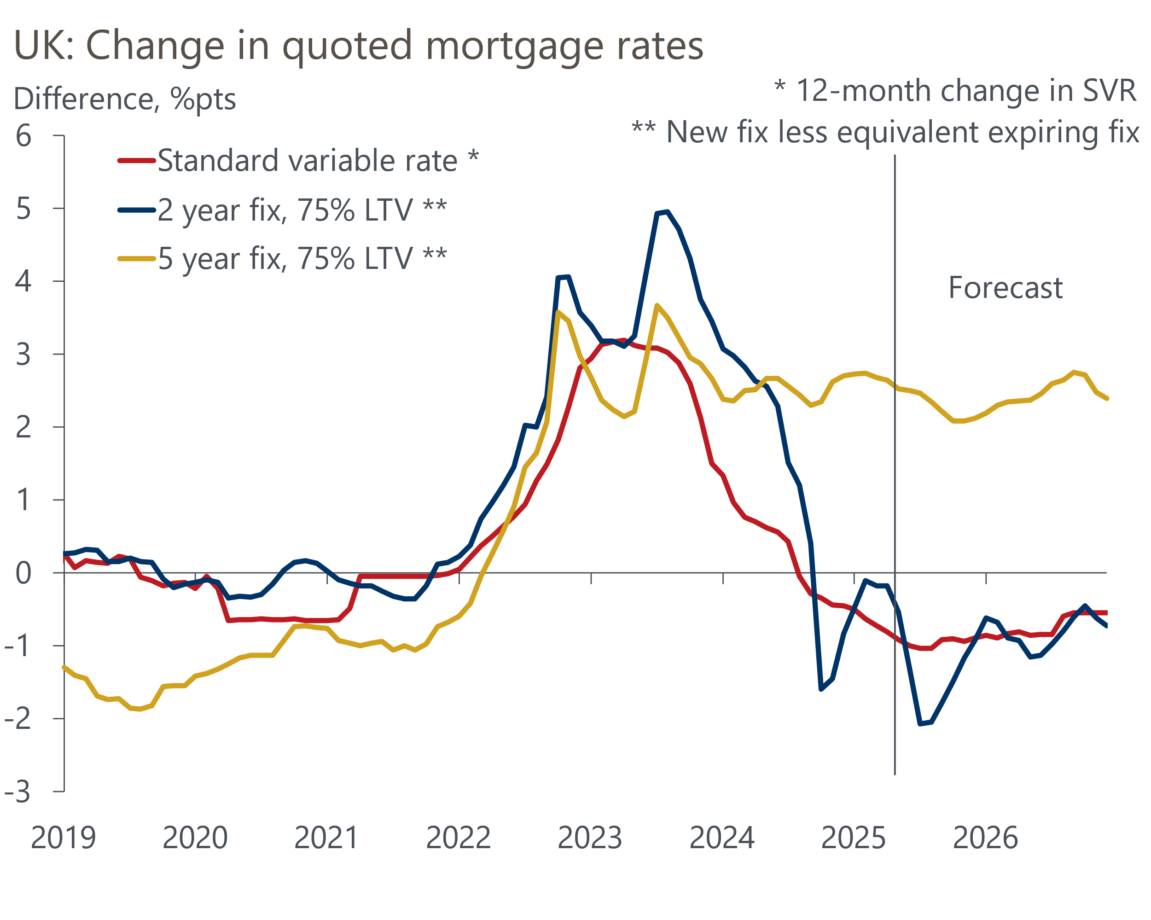
Sources: Oxford Economics, Haver Analytics
At the same time, the transmission of monetary policy to interest rates payable on household savings has been much quicker. With policy still clearly in restrictive territory and the BoE's Monetary Policy Committee continuing to lower Bank Rate, interest receipts are likely to fall further. So, we expect net interest income to increasingly weigh on real household disposable incomes for mortgagors.
Consumers have exercised extreme caution in recent years, and whether this continues will play a key role in shaping the broader growth outlook over the next few years. Surveys suggest consumer sentiment is starting to firm, and this should mean households will be keener to spend and take on more credit moving forwards. But in combination with the drags from softer real pay growth and the freeze on most income tax thresholds and allowances, we think the lagged impact of past interest rate rises will play a role in preventing consumer spending growth from materially outperforming the growth in household incomes.

The week ahead
The first of next week's two major economic releases is the inflation data for June. CPI inflation edged down to 3.4% in May and we estimate that the headline rate remained at 3.4% in June. This reflects a series of offsetting forces, with modest upward pressure from a smaller drag from the petrol category and base effects in the core goods category likely to be counterbalanced by softer services inflation.
Next week will also see the release of the labour market data for March-May. A combination of cooling momentum and February's strong single-month earnings outturn falling out of the three-month average means we forecast total pay growth will slow to 5%, while regular pay growth is expected to fall to 4.9% in the three months to May.
On the quantities side, recent Labour Force Survey results for unemployment have continued to tick up. HMRC reported a particularly large fall in the count of employees on company payrolls in May, and though there has been a tendency for early HMRC estimates of employee numbers to be revised upwards over time, the scale of May's drop suggests the weakness is unlikely to be fully revised away. Therefore, we think a higher single-month unemployment reading in May will lift the three-month average to 4.7%.
Table 1: Week ahead calendar
Date | Events | Period | Measure | Unit | Previous | Forecast
Jul 16 | CPI inflation | Jun | m/m | % | 0.2 | 0.2
Jul 16 | CPI inflation | Jun | y/y | % | 3.4 | 3.4
Jul 16 | RPI inflation | Jun | m/m | % | 0.2 | 0.4
Jul 16 | RPI inflation | Jun | y/y | % | 4.3 | 4.4
Jul 16 | Land Registry house prices | May | y/y | % | 3.4 | 2.9
Jul 17 | LFS unemployment | Mar-May | Rate | % | 4.6 | 4.7
Jul 17 | Average earnings (total pay) | May | 3m, y/y | % | 5.3 | 5.0
Jul 17 | Average earnings (regular pay) | May | 3m, y/y | % | 5.2 | 4.9
Source: Oxford Economics

Key forecasts
Table 2: UK forecast overview
(Annual percentage changes unless specified)
 | 2023 | 2024 | 2025 | 2026 | 2027 | 2028
GDP | 0.4 | 1.1 | 1.1 | 0.9 | 1.3 | 1.8
Private consumption | 0.5 | 0.6 | 1.1 | 1.1 | 1.2 | 1.7
Fixed investment | 0.3 | 1.5 | 1.8 | 0.8 | 1.6 | 2.0
Government consumption | 1.6 | 3.0 | 1.5 | 1.7 | 1.6 | 1.7
Exports of goods and services | -0.4 | -1.2 | 0.9 | -0.6 | 1.2 | 1.4
Imports of goods and services | -1.2 | 2.7 | 2.3 | -0.9 | 1.1 | 1.4
Industrial Production | -0.8 | -1.2 | 0.0 | -0.5 | 0.7 | 1.2
Consumer prices | 7.3 | 2.5 | 3.3 | 2.5 | 2.3 | 2.1
Unemployment rate (%) | 4.1 | 4.3 | 4.7 | 4.9 | 4.8 | 4.5
Current a/c balance (% of GDP) | -3.5 | -2.7 | -3.0 | -2.8 | -2.7 | -2.6
Government balance (% of GDP) | 5.2 | 5.1 | 4.3 | 3.6 | 3.0 | 2.7
Central bank policy rate (%, EOP) | 5.25 | 4.75 | 3.75 | 3.00 | 2.50 | 2.50
10yr govt. bond yield (%, EOP) | 3.54 | 4.57 | 4.54 | 4.03 | 3.47 | 3.35
Exchange rate (US$ per £, EOP) | 1.27 | 1.25 | 1.36 | 1.36 | 1.36 | 1.36
Exchange rate (euro per £, EOP) | 1.15 | 1.21 | 1.17 | 1.17 | 1.17 | 1.17
Source: Oxford Economics
Table 3: Quarterly forecasts for the UK
 | 2025 |  |  |  | 2026
 | Q1 | Q2 | Q3 | Q4 | Q1 | Q2 | Q3 | Q4
GDP (% year) | 1.3 | 0.9 | 1.1 | 1.2 | 0.7 | 0.8 | 0.9 | 1.0
CPI inflation (% year) | 2.8 | 3.4 | 3.6 | 3.3 | 3.1 | 2.2 | 2.3 | 2.4
Bank Rate (%, EOP) | 4.50 | 4.25 | 4.00 | 3.75 | 3.50 | 3.25 | 3.25 | 3.00
10yr gilt yield (%, EOP) | 4.70 | 4.48 | 4.60 | 4.54 | 4.46 | 4.34 | 4.19 | 4.03
US$ per £ (EOP) | 1.29 | 1.37 | 1.36 | 1.36 | 1.36 | 1.36 | 1.36 | 1.36
Euro per £ (EOP) | 1.20 | 1.17 | 1.17 | 1.17 | 1.17 | 1.17 | 1.17 | 1.17
Source: Oxford Economics

Latest Country Economic Forecast:
June 17, 2025

Recent publications

Data Insights
GDP falls again as momentum slows
PMIs suggest growth was relatively soft in Q2
Manufacturing sector struggles on
Mortgage activity recovers as stamp duty distortions start to fade
Headwinds to growth are intensifying

Research Briefings
How the sectoral mix of jobs is changing and what it means
MPC’s dovish hold boosts the chances of an August cut
MPC Preview – Divided committee to pause in June
Unconvincing spending review is another fiscal stopgap
Tough fiscal choices looming in the Autumn

Contacts

Oxford Economics' UK team
- Andrew Goodwin - Chief UK Economist - agoodwin@oxfordeconomics.com
- Edward Allenby - UK Economist - eallenby@oxfordeconomics.com

